Critical Patch Installation

CPS16

**Version V 1.0**

**Author**

Mansi Nikam

Associate IT Consultant

|  |
| --- |
| **Document Control** |

**Document History**

|  |  |  |  |
| --- | --- | --- | --- |
| **Issue** | **Date** | **Maintainer / Owner** | **Description** |
| 1.0 | 13/05/2020 | Mansi Nikam |  |
|  |  |  |  |
|  |  |  |  |
|  |  |  |  |
|  |  |  |  |

**Review**

|  |  |
| --- | --- |
| **Name** | **Role** |
| Rajvina Yakub | Lead Consultant |
|  |  |
|  |  |

**Approval History**

|  |  |  |
| --- | --- | --- |
| **Approver** | **Approval Date** | **Comments** |
|  |  |  |
|  |  |  |

Table of Contents

[1. Backups 4](#_Toc24459013)

[2. Run setup 5](#_Toc24459014)

[3. Check Windchill Version 13](#_Toc24459015)

[4. Start Windchill 14](#_Toc24459016)

# Backups

Before starting the patch installation, take the following backups(**Will be done by Camso)**:

1. Windchill Folder
2. Database
3. LDAP backup

Navigate to the below location. Run control-panel.bat.

Machine generated alternative text:
r-r¯r- 
computer DATA 
PTC 
• Windchill 
Organize 
Favorites 
z 
Deskh:p 
Downloads 
Recent Places 
Libraries 
Documents 
Print New Folder 
Name 
backup 
base64 
control-panel 
dbtest 
dsconfig 
dsframenork 
Il.x • WindchillD5 • server • ba 
Date modified 
811312015 11 
811312015 11 
811312015 11 
811312015 11 
811312015 11 
811312015 11 
AM 
AM 
AM 
AM 
AM 
AM 
Windows Batch File 
Windows Batch File 
Windows Batch File 
Windows Batch File 
Windows Batch File 
Windows Batch File 

Login with ldap paddword (ldapadmin)

Machine generated alternative text:
Z PTC Windchill Directory Server Control Panel 
Select the server that you want to administer: 
- Ser... 
r-r¯r- 
Local Server 
Instance Path: 
Bind DN: 
Password: 
E: XPTQWindchiII_I I 
cn=Manager 

Machine generated alternative text:
a PTC Windchill Directory Server Control Panel 
r-r¯r- 
File View Help 
Directory Data 
Manage Entries 
New Base DN.. 
Import LDIF.. 
Export LDIF... 
Backup... 
Restore.. 
Schema 
Indexes 
Monitoring 
Runtime Options 
Server Status 
Server Status: 
Started 
Open Connections: 20 
Server Details 
Host Name: 
Administrative Users: 
Installation Path: 
Version: 
Java Version: 
Administration Connector. 
Connection Handlers 
Address:Port 
plm-qa. csl.local 
cn=Manager 
E: XPTQWindchiII_I I 
PTC Windchill Directory Server 2.6.O-8uiId_007 
• Port 4444 (LDAP5) 
Protocol 
0.0.0.0:8080 
Data Sources 
Base DN 
LDIF 
LDAP 
L DAPS 
Backend ID 
userRoot 
Entries 
Disabled 
Enabled 
Disabled 
Enabled 
Disabled 
Replication 

Give the name for the backup file

Machine generated alternative text:
Z PTC Windchill Directory Server Control Panel 
- Export LDIF 
Backend: 
Export to File: 
Export Options: 
userRoot 
E: ibackup\LDAP _backup\LDAP _backup_OSI 1201 g. IdiF 
r-r¯r- I 
Browse... 
r 
IF File exists, overwrite contents OF File instead OF appending. 
Launch non 
Change... 
r 
Compress Data 
r 
Wrap Text at Column 
Data Exclusion Options 
pata ppCiop$ 

# Run setup

Run the setup.vbs from PSI folder.

Machine generated alternative text:
PTC Solution Installer 11.0 
• Computer 
ganize 
Favorites 
z 
Deskh:p 
Downloads 
Recent Places 
Libraries 
Documents 
Pictures 
Videos 
DATA QA_Staging2 
Print New Folder 
Name 
installer _jres 
autorun 
version 
• PTC Solution Installer 11.0 • 
Date modified 
612812017 8. 
•28 AM 
612812017 8. 
•28 AM 
61212017 11 
AM 
61212017 11 
AM 
61212017 11 
AM 
61212017 1:46 PM 
File Folder 
File Folder 
Setup Information 
VBScript Script File 
XML Document 

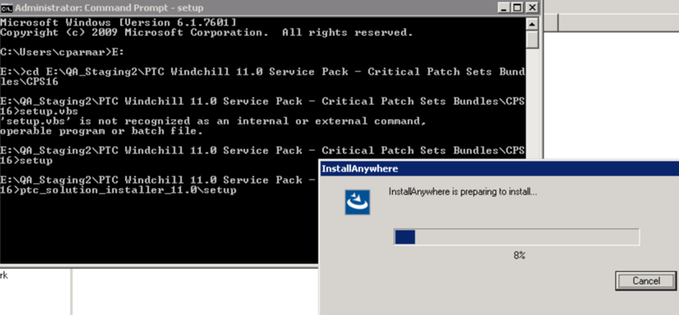

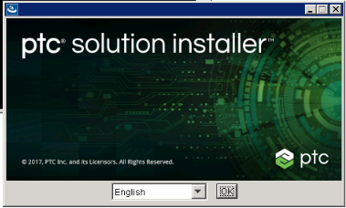

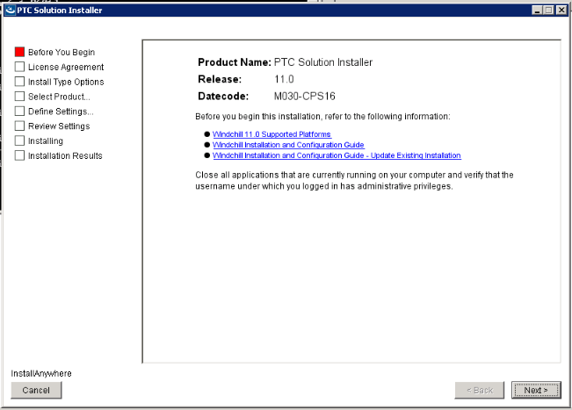

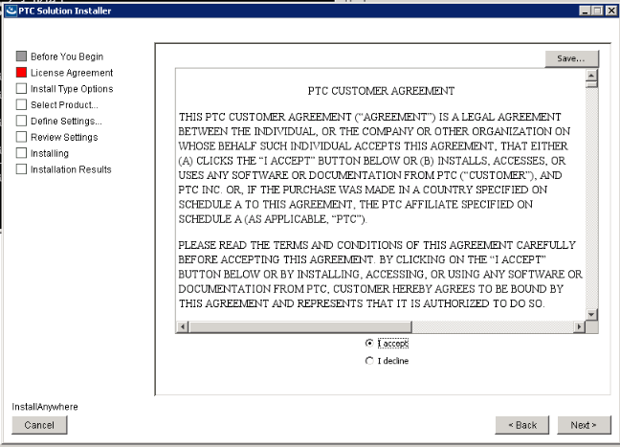

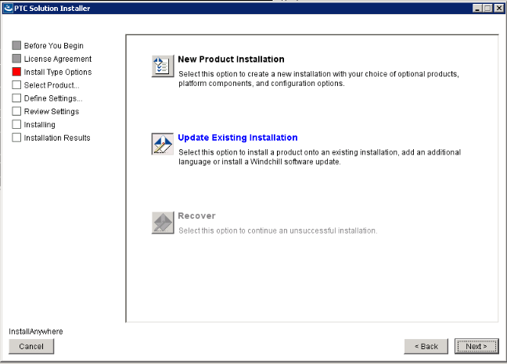

ss

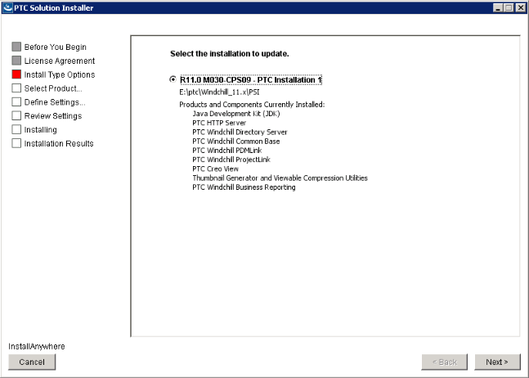

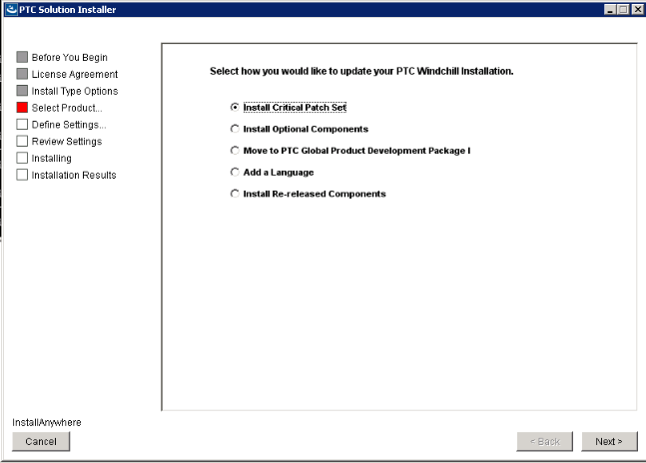

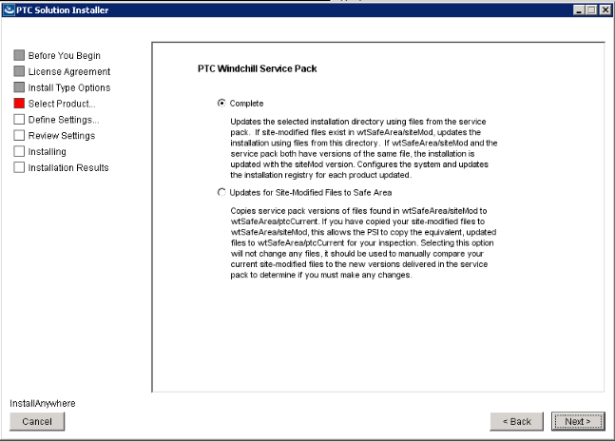

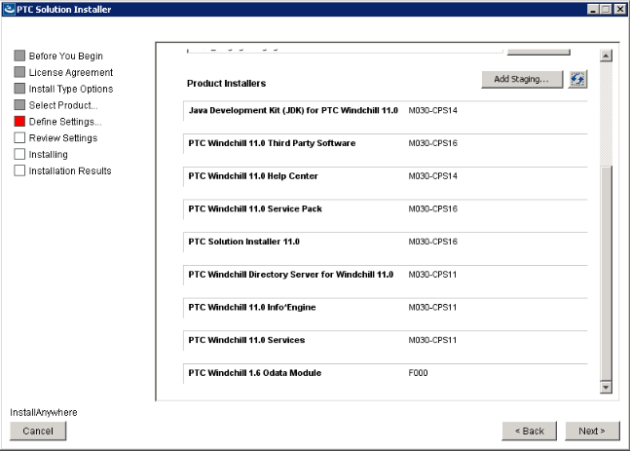

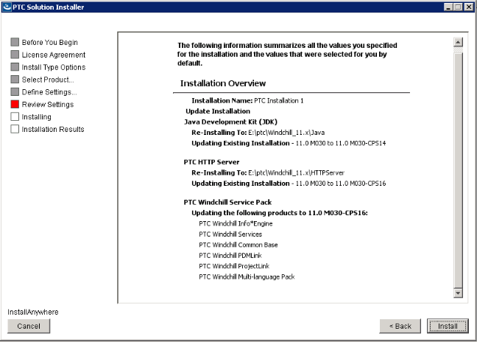

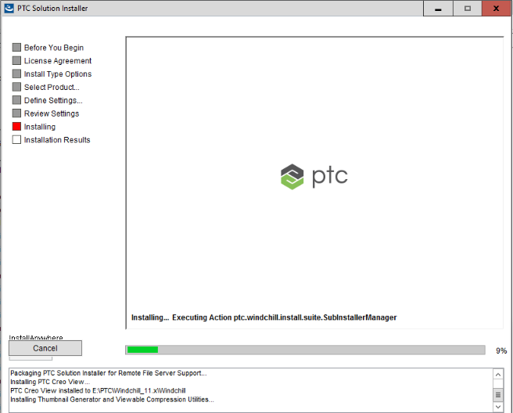

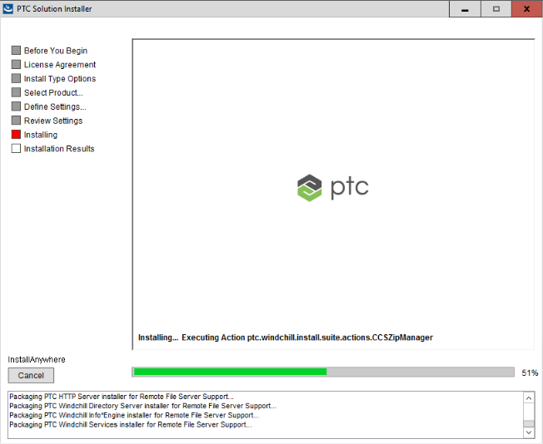

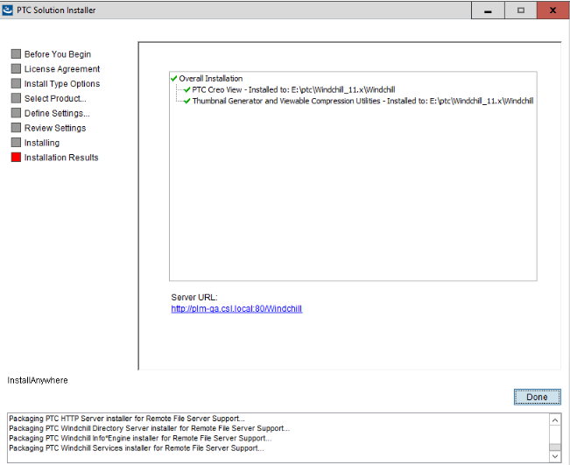

# Check Windchill Version

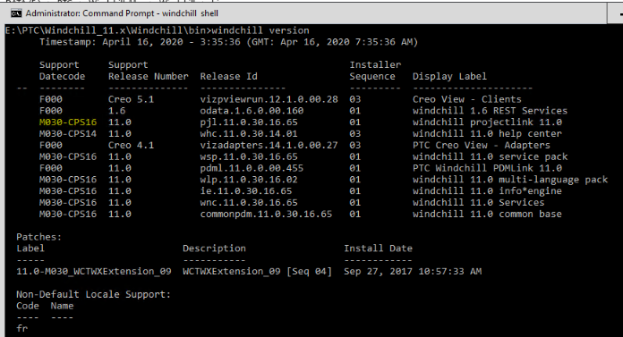

Patch has been updated.

# Start Windchill

Run the update tool:

update\_tool -username itcadmin -password Infotech14! -noui

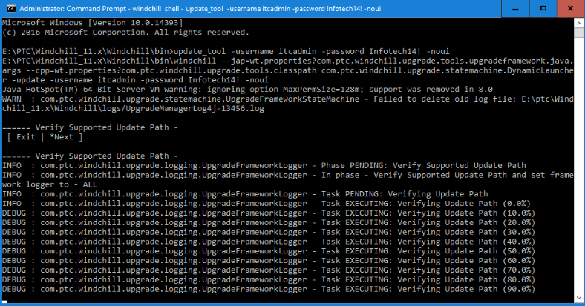

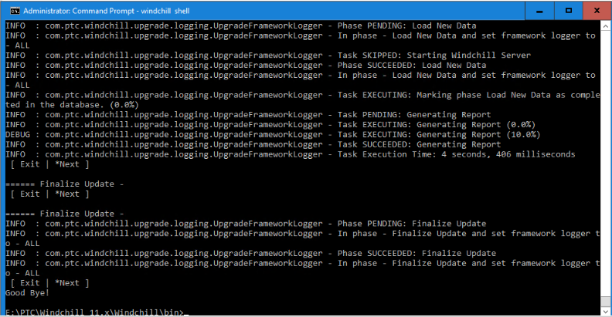

**Windchill started successfully.**